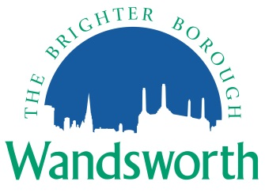
Wandsworth Borough Council

Local Planning Application Requirement Checklist

Application for Removal or Variation of a Condition following
grant of planning permission

Please indicate on the form below the information you are providing with your application including the document file names if you are providing the documents electronically. To ensure that your application is valid it is important that you provide all the information indicated in the Council’s Planning Application Requirements. These are available on the Council’s website at:

http://www.wandsworth.gov.uk/downloads/file/4933/planning_application_requirements

Please provide 2 copies of all relevant material if applying on paper.
The Council requests that all plans and drawings should indicate: drawing number; paper size (preferably A3); key dimensions; and a scale bar indicating a minimum of 0-10 metres.

Application Details
Applicant
Site Address
Date

Requirement | Provided – please tick/delete as appropriate | Document file name(s) – if supplying electronically
Completed application form and Certificates | Yes No
Design and Access Statement | Yes No
Appropriate fee | Yes No
Notice(s) | Yes No
Completed application form and Certificates | Yes No
Design and Access Statement | Yes No
Affordable housing viability requirements:  - Executive Summary  - Viability Assessment  - Redacted Viability Assessment | Yes No
Acoustic and odour assessment | Yes No
Air quality assessment | Yes No
Biodiversity survey and report | Yes No
BREEAM Assessment | Yes No
Community Infrastructure Levy Planning Application Additional Information Form | Yes No
Construction method statement | Yes No
Contaminated land assessment | Yes No
Cultural Action Plan | Yes No
EIA | Yes No
Flood risk assessment | Yes No
Foul sewage and utilities statement | Yes No
Hard/Soft landscaping | Yes No
Health Impact Assessment | Yes No
Heliport Requirements | Yes No
Lighting assessment | Yes No
Marketing report and justification statement | Yes No
Noise impact assessment | Yes No
Open space assessment | Yes No
Planning statement | Yes No
Retail Impact Assessment | Yes No
Schedule of work affecting listed buildings | Yes No
Sequential test assessment | Yes No
Statement of community involvement | Yes No
Student housing requirement | Yes No
Sustainability and energy assessment | Yes No
Tall building impact assessment | Yes No
Transport statement & Parking survey | Yes No
Transport assessment | Yes No
Travel plan | Yes No
Tree survey/arboricultural statement | Yes No
Waste/site waste management plan | Yes No

